Tobii Matlab Data Analysis Stanford

- Figures and Plotting
figure - create a figure window
hold on - hold figure so that new plot elements will add to (not replace) existing elements
plot - draw lines
scatter - draw a scatter plot
bar - draw bar chart
hist - draw histogram
image, imagesc - draw a 2D matrix as an image
axis - obtain or change axis bounds
xlabel, ylabel - add a label to the x- or y-axis
title - add a title
legend - add a legend
colormap - obtain or change the colormap
colorbar - add a colorbar
get - get properties of a plot element
set - set properties of a plot element
gcf - get handle of current figure
gca - get handle of current axis
print - print figure to an image file (e.g. PNG, EPS)
close - close figure window
subplot - split a figure into multiple smaller plots

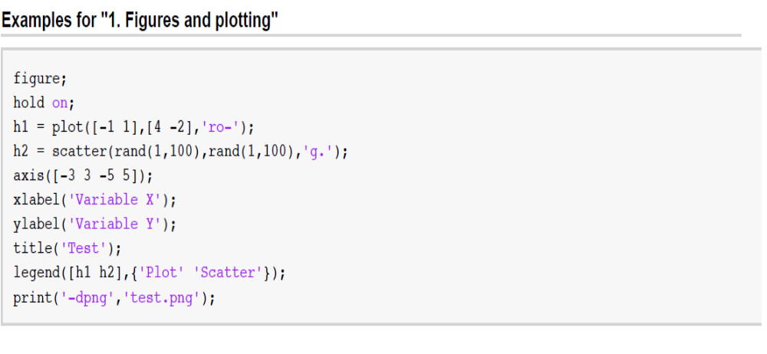

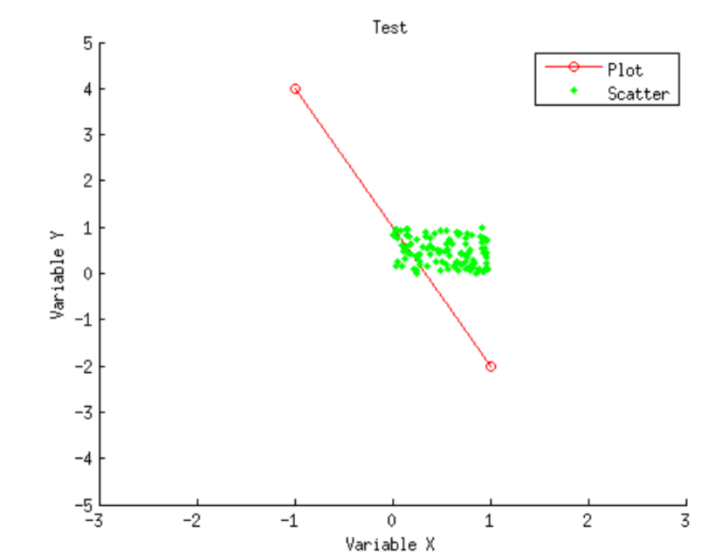

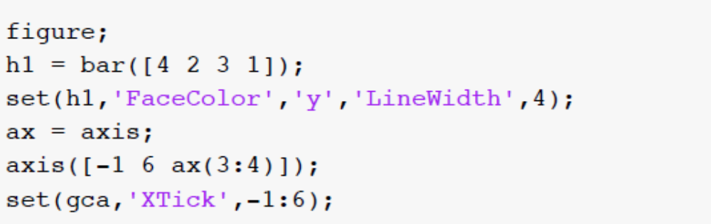
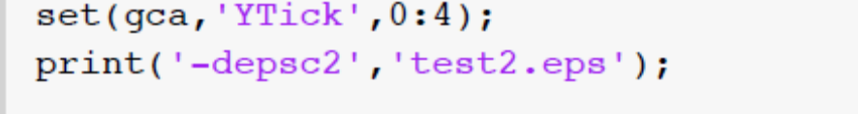

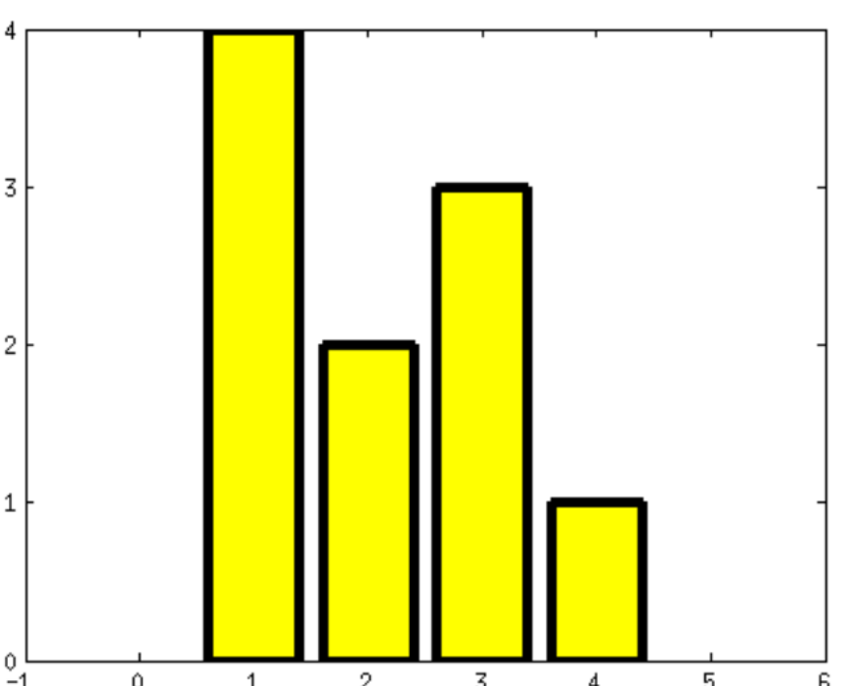

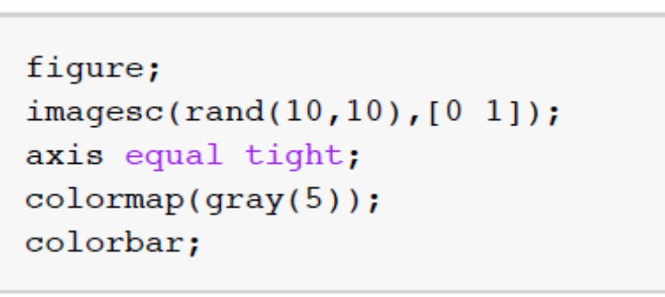

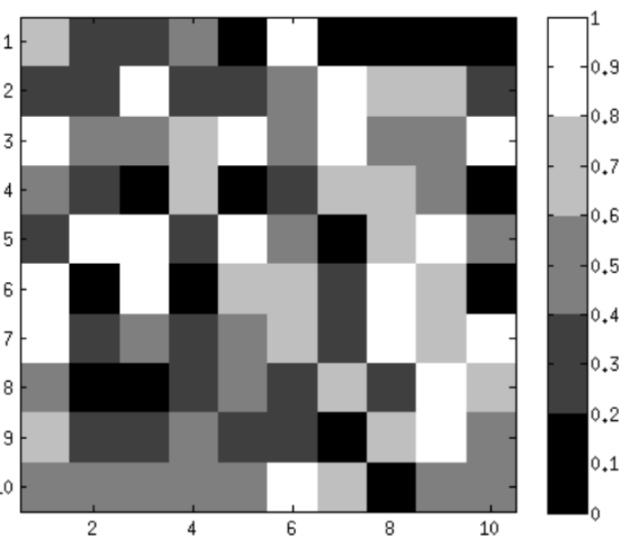

- Flow Control

if ... else ... end - if something is true, do this; otherwise, do that
while ... end - while some condition is true, repeat statements
for ... end - for each iteration, repeat statements
switch ... case ... end - execute different statements depending on value of a variable
break - exit a for- or while-loop prematurely
continue - jump to the next iteration in a for- or while-loop

- Boolean operators
&& - if something is true AND something is true
|| - if something is true OR something is true
~ - NOT all - return true if all elements are true any - return true if any element is true
all - return true if all elements are true
any - return true if any element is true

- Path issues
The path is a collection of directories within which MATLAB searches for .m files. In order for MATLAB to recognize the existence of a function (or script), that function (or script) must exist on the path. - The current working directory is automatically included in the path.- If there are multiple .m files that share the same name, one of the files takes precedence. To determine which file has precedence, use the which command.

- Path-related commands
path - get the current path
addpath - add to the path
genpath - create a path string from a directory, including all sub-directories

- Writing functions

- Writing good functions is extremely important; if done well, programming complex software can become easy. - A good function is general (i.e. it can be re-used for different situations) and well-documented (i.e. the inputs and outputs of the function are clearly described). - To add comments, use the % symbol. Text following the % symbol is ignored by MATLAB. - Simple example of a function:

- Functions can have multiple inputs and multiple outputs. Example of the syntax:
[a,b] = computesomething(x,y)

- Function handles, anonymous functions

The @ symbol allows one to create a function handle, which is a reference to a function. Function handles are useful for passing functions to functions. - The @ symbol also allows one to create an anonymous function. An anonymous function is a function that is defined on-the-fly and does not have an .m file associated with it. Anonymous functions can make certain programming tasks easier (since one does not have to create and save .m files)

- 8. Debugging –

If MATLAB crashes, the last command you issued in the command window does not take effect (e.g. if the command was an assignment, the assignment does not occur). - To help figure out why the crash happened (if it isn't already obvious from the error message), you can use MATLAB's built-in debugger.- The debugger essentially allows you to step through your code one line at a time. After each step, you can check the workspace, check the contents of variables, and/or issue MATLAB commands, which can all be useful for figuring out what's going on. - The GUI includes various buttons and widgets that can be helpful when debugging.

dbstop - tell MATLAB when (i.e. in what function) to enter debugging mode
dbstep - in debugging mode, this tells MATLAB to execute the next line of code
dbstep in - like dbstep except that we step into function calls (so that we can debug them)
dbcont - in debugging mode, this tells MATLAB to execute all remaining lines of code
dbquit - in debugging mode, this tells MATLAB to get out of debugging mode
dbclear - clear debugging breakpoints set by dbstop

- Probability distribution and error bars:

Exploring a simple dataset: one variable, one condition

histogram provides a useful summary of a set of data

mean and standard deviation are simple summaries of a set of data

They are parametric
statistics, as they make implicit assumptions about the form of the data. The mean is designed to
quantify the central tendency of a set of data, while the standard deviation is designed to quantify the spread of a set of data.

